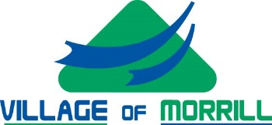

Village of Morrill KENO Funds Request

Use of Proceeds
Pursuant to the Nebraska County and City Lottery Act, all proceeds received by the Village of Morrill from the keno-type lottery must be used only for community betterment purposes. The Board of Trustees has established the Keno Fund and certain rules and regulations regarding the distribution for the keno lottery proceeds.
Any funds that are not allocated will remain in the Keno fund for use the following year.

Allocations of the Keno funds will be awarded at the discretion of the Village of Morrill Board of Trustees.

All Keno Fund requests must be an agenda item, the funds request form must be filled out and there needs to be representation at the Board of Trustee meeting to make the request to the Board and answer any questions.

If award is received, failure to use funds as identified will result in the loss of opportunity to submit future requests. The project must be completed within a year of the time the funds are received. If funds are not used for the awarded project, they must be returned to the Village of Morrill in able to remain in good standing.

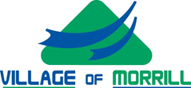
Village of Morrill KENO Funds Request

Application Form

Requesting Organization Information

Requesting Organization:
Organization Location: __________________________________________________
Years of Organization Existence:
Contact Name:
Organization Address:
City: State: Zip:
Daytime Phone:
Email Address:

Target Population to be served:
Program/Project Name:
Project Start Date: Project Completion Date:
Amount Requested: $
Partial funding accepted: Yes ______ No _______
Matching funding or other monies available toward completion of project:

Funding Request Summary
Please provide a summary of information according to the numbered items below. All information must be factual and accurate as reported.

1. Describe the agency requesting funds and its mission.

Village of Morrill KENO Funds Request

2. Project budget (Identify all income and costs for the project including future costs.)

3. Describe any collaborations or affiliations with other organizations or businesses.

4. Project justification (Why is the project needed?)
_____________________________________________________________________________________

The Applicant hereby assumes that the organization intends to provide services according to the information contained in this request if selected and funded to do so.

Signature of certifying official Date

Printed Name of certifying official

FOR OFFICE USE ONLY

DATE RECEIVED:

DATE OF REVIEW BY MORRILL BOARD OF TRUSTEES: ________________________

APPROVED: ___________ NOT APPROVED: _________________

AMOUNT APPROVED: __________ LETTER OF REQUEST: ________________

